AI_BASED DIABETES PREDICTION SYSTEM USING MACHINE LEARNING.

TEAM MEMBER

922321106016:Mani Priya Paramasivam

Phase 3: Development part 1

Topic: Start building the AI_Based diabetes prediction model by loading and pre-processing the dataset.



AI_BASED DIABETES PREDICTION SYSTEM USING MACHINE LEARNING.

Introduction: In this phase we begin developing the diabetes prediction system by preparing the data and selecting relevant features. Loading and preprocessing data are crucial steps in building an AI-based diabetes prediction system. Proper data handling sets the foundation for developing an accurate and effective predictive model. This phase provides an overview of the significance and process of loading and preprocessing data for such a system.

Given Dataset:

|  |  |  |  |  |  |  |  |  |
| --- | --- | --- | --- | --- | --- | --- | --- | --- |
| Pregnancies | Glucose | Blood  Pressure | Skin  Thickness | Insulin | BMI | Diabetes  Pedigree Function | Age | Out  come |
| 6 | 148 | 72 | 35 | 0 | 33.6 | 0.627 | 50 | 1 |
| 1 | 85 | 66 | 29 | 0 | 26.6 | 0.351 | 31 | 0 |
| 8 | 183 | 64 | 0 | 0 | 23.3 | 0.672 | 32 | 1 |
| 1 | 89 | 66 | 23 | 94 | 28.1 | 0.167 | 21 | 0 |
| 0 | 137 | 40 | 35 | 168 | 43.1 | 2.288 | 33 | 1 |
| 5 | 116 | 74 | 0 | 0 | 25.6 | 0.201 | 30 | 0 |
| 3 | 78 | 50 | 32 | 88 | 31 | 0.248 | 26 | 1 |
| 10 | 115 | 0 | 0 | 0 | 35.3 | 0.134 | 29 | 0 |
| 2 | 197 | 70 | 45 | 543 | 30.5 | 0.158 | 53 | 1 |
| 8 | 125 | 96 | 0 | 0 | 0 | 0.232 | 54 | 1 |
| 4 | 110 | 92 | 0 | 0 | 37.6 | 0.191 | 30 | 0 |
| 10 | 168 | 74 | 0 | 0 | 38 | 0.537 | 34 | 1 |
| 10 | 139 | 80 | 0 | 0 | 27.1 | 1.441 | 57 | 0 |
| 1 | 189 | 60 | 23 | 846 | 30.1 | 0.398 | 59 | 1 |

Excel Dataset link: <https://in.docworkspace.com/d/sIETqyObiAYe6s6kG>

769 rows *9 columns

Necessary steps to follow:

To create an AI-based diabetes prediction system, you'll need to load and work with a dataset that contains relevant information. Here are the key steps and considerations for loading a dataset:

1.Data Collection: Gather a dataset that includes historical information about individuals, particularly features that are relevant to diabetes prediction. Common features might include age, gender, body mass index (BMI), blood pressure, glucose levels, family history, and more.

2.Data Preprocessing: Clean the dataset to handle missing values, outliers, and inconsistencies. This may involve imputing missing values, scaling features, and encoding categorical variables.

3.Dataset Splitting: Split the dataset into training, validation, and test sets. This helps in training your AI model, tuning hyperparameters, and evaluating its performance.

4.Feature Selection: Identify the most relevant features for diabetes prediction. Feature selection techniques can help in reducing dimensionality and improving model efficiency.

5.Data Normalization: Normalize or standardize the data to ensure that different features are on a similar scale. This can improve the performance of many machine learning algorithms.

6.Loading into Your AI System: Depending on the programming language and libraries you're using; you can load the dataset into your AI system. Popular libraries for this purpose include NumPy, Pandas, and scikit-learn in Python.

* Steps to be continued after loading and preprocessing the dataset.

7.Building the Model: Train your AI model, which can be a machine learning model (e.g., logistic regression, decision tree, random forest) or a deep learning model (e.g., neural network). Your model will use the loaded dataset to learn patterns and make predictions.

8.Evaluation: Assess the performance of your model using appropriate metrics like accuracy, precision, recall, F1-score, or area under the ROC curve (AUC). Tweak your model and dataset as needed for better results.

9.Deployment: Once your AI-based diabetes prediction system performs well, you can deploy it in a real-world environment where it can make predictions for new data.

10.Monitoring and Maintenance: Continuously monitor the system's performance and update the dataset and model as new data becomes available.

Loading the Dataset:

Data Collection: Obtain a dataset that contains relevant information for diabetes prediction. You can find such datasets from sources like the National Institute of Diabetes and Digestive and Kidney Diseases (NIDDK) or the UCI Machine Learning Repository.

Choose a Programming Language and Libraries: Select a programming language (e.g., Python) and libraries (e.g., Pandas) to work with your dataset. Python is commonly used for data science and machine learning tasks.

Load the Dataset: Use library functions to load your dataset. For example, in Python, you can use Pandas to read data from CSV, Excel, or other file formats.

Data Preprocessing:

Handling Missing Values: Check for and handle missing values. You can either remove rows with missing values or impute them using techniques like mean, median, or regression imputation.

Dealing with Outliers: Identify and handle outliers in your dataset. You can use statistical methods or visualization techniques to detect outliers and then decide whether to remove or transform them.

Feature Engineering: Create new features or transform existing ones to make them more suitable for your model. For example, you can compute the body mass index (BMI) if it's not already in the dataset.

Data Scaling: Normalize or standardize numerical features to ensure they are on the same scale. This is important, especially if you plan to use algorithms sensitive to feature scaling, like support vector machines or k-nearest neighbors.

Encoding Categorical Variables: If your dataset contains categorical variables, encode them into numerical values. One-hot encoding is a common technique for this purpose.

Split the Data: Divide your dataset into training, validation, and test sets. This is important for model training, hyperparameter tuning, and evaluation.

* With the dataset loaded and preprocessed, you can proceed to build and train your diabetes prediction model using machine learning or deep learning techniques.

PROGRAM:

import warnings  
warnings.filterwarnings('ignore')

import numpy as np   
*import* pandas as pd

IMPORTING SEABORN LIBRARY FOR STATISTICAL DATA VISUALIZATION

import seaborn as sns

IMPORTING MATPLOTLIB LIBRARY FOR CREATING PLOTS AND VISUALIZATIONS   
import matplotlib.pyplot as plt

IMPORTING PLOTLY EXPRESS LIBRARY FOR INTERACTIVE VISUALIZATIONS

import plotly.express as px

Exploratory Data Analysis (EDA): It is a critical step in understanding and gaining insights from your dataset in an AI-based diabetes prediction system.

LOAD AND PREPARE DATA

df=pd.read_excel(‘<https://in.docworkspace.com/d/sIETqyObiAYe6s6kG> ‘)

UNDERSTANDING THE VARIABLES

INPUT

df.head(10)

OUTPUT

|  |  |  |  |  |  |  |  |  |  |
| --- | --- | --- | --- | --- | --- | --- | --- | --- | --- |
| S:NO | pregnancies | Glucose | Blood  pressure | Skin  thickness | insulin | BMI | Diabetespedigree  function | Age | Out  come |
| 0 | 6 | 148 | 72 | 35 | 0 | 33.6 | 0.627 | 50 | 1 |
| 1 | 1 | 85 | 66 | 29 | 0 | 26.6 | 0.351 | 31 | 0 |
| 2 | 8 | 183 | 64 | 0 | 0 | 23.3 | 0.672 | 32 | 1 |
| 3 | 1 | 89 | 66 | 23 | 94 | 28.1 | 0.167 | 21 | 0 |
| 4 | 0 | 137 | 40 | 35 | 168 | 43.1 | 2.288 | 33 | 1 |
| 5 | 5 | 116 | 74 | 0 | 0 | 25.6 | 0.201 | 30 | 0 |
| 6 | 3 | 78 | 50 | 32 | 88 | 31.0 | 0.248 | 26 | 1 |
| 7 | 10 | 115 | 0 | 0 | 0 | 35.3 | 0.134 | 29 | 0 |
| 8 | 2 | 197 | 70 | 45 | 543 | 30.5 | 0.158 | 53 | 1 |
| 9 | 8 | 125 | 96 | 0 | 0 | 0.0 | 0.232 | 54 | 1 |

INPUT

df.tail(10)

OUTPUT

|  |  |  |  |  |  |  |  |  |  |
| --- | --- | --- | --- | --- | --- | --- | --- | --- | --- |
| S:NO | pregnancies | Glucose | Blood  Pressure | Skin  Thickness | Insulin | BMI | Diabetespedigree  function | Age | Out  come |
| 758 | 1 | 106 | 76 | 0 | 0 | 37.5 | 0.197 | 26 | 0 |
| 759 | 6 | 190 | 92 | 0 | 0 | 35.5 | 0.278 | 66 | 1 |
| 760 | 2 | 88 | 58 | 26 | 16 | 28.4 | 0.766 | 22 | 0 |
| 761 | 9 | 170 | 74 | 31 | 0 | 44.0 | 0.403 | 43 | 1 |
| 762 | 9 | 89 | 62 | 0 | 0 | 22.5 | 0.142 | 33 | 0 |
| 763 | 10 | 101 | 76 | 48 | 180 | 32.9 | 0.171 | 63 | 0 |
| 764 | 2 | 122 | 70 | 27 | 0 | 36.8 | 0.340 | 27 | 0 |
| 765 | 5 | 121 | 72 | 23 | 112 | 26.2 | 0.245 | 30 | 0 |
| 766 | 1 | 126 | 60 | 0 | 0 | 30.1 | 0.349 | 47 | 1 |
| 767 | 1 | 93 | 70 | 31 | 0 | 30.4 | 0.315 | 23 | 0 |

INPUT

df.sample(5)

OUTPUT

|  |  |  |  |  |  |  |  |  |  |
| --- | --- | --- | --- | --- | --- | --- | --- | --- | --- |
| S:NO | Pregnancies | Glucose | Blood  Pressure | Skin  Thickness | Insulin | BMI | Diabetespedigree  function | Age | Out  come |
| 345 | 8 | 126 | 88 | 36 | 108 | 38.5 | 0.349 | 49 | 0 |
| 578 | 10 | 133 | 68 | 0 | 0 | 27.0 | 0.245 | 36 | 0 |
| 84 | 5 | 137 | 108 | 0 | 0 | 48.8 | 0.227 | 37 | 1 |
| 217 | 6 | 125 | 68 | 30 | 120 | 30.0 | 0.464 | 32 | 0 |
| 595 | 0 | 188 | 82 | 14 | 185 | 32.0 | 0.682 | 22 | 1 |

INPUT

df.describe()

OUTPUT

|  |  |  |  |  |  |  |  |  |  |
| --- | --- | --- | --- | --- | --- | --- | --- | --- | --- |
| S:NO | Pregnancies | Glucose | Blood  pressure | Skin  Thickness | Insulin | BMI | DiabetesPedigreeFunction | Age | Out  come |
| count | 768.000000 | 768.000000 | 768.000000 | 768.000000 | 768.000000 | 768.000000 | 768.000000 | 768.000000 | 768.000000 |
| mean | 3.845052 | 120.894531 | 69.105469 | 20.536458 | 79.799479 | 31.992578 | 0.471876 | 33.240885 | 0.348958 |
| std | 3.369578 | 31.972618 | 19.355807 | 15.952218 | 115.244002 | 7.884160 | 0.331329 | 11.760232 | 0.476951 |
| min | 0.000000 | 0.000000 | 0.000000 | 0.000000 | 0.000000 | 0.000000 | 0.078000 | 21.000000 | 0.000000 |
| 25% | 1.000000 | 99.000000 | 62.000000 | 0.000000 | 0.000000 | 27.300000 | 0.243750 | 24.000000 | 0.000000 |
| 50% | 3.000000 | 117.000000 | 72.000000 | 23.000000 | 30.500000 | 32.000000 | 0.372500 | 29.000000 | 0.000000 |
| 75% | 6.000000 | 140.250000 | 80.000000 | 32.000000 | 127.250000 | 36.600000 | 0.626250 | 41.000000 | 1.000000 |
| max | 17.000000 | 199.000000 | 122.000000 | 99.000000 | 846.000000 | 67.100000 | 2.420000 | 81.000000 | 1.000000 |

INPUT

df.size

OUTPUT

6912

INPUT

df.shape

OUTPUT

(768, 9)

Data cleaning: It can be a complex and domain-specific process. The specific steps and techniques you use may vary depending on your dataset and the nature of the data quality issues.

INPUT

df=df.drop_duplicates()

Df.shape

OUTPUT

(768, 9)

CHECK FOR NULL VALUES

INPUT

df.isnull().sum()

OUTPUT

Pregnancies 0  
Glucose 0  
BloodPressure 0  
SkinThickness 0  
Insulin 0  
BMI 0  
DiabetesPedigreeFunction 0  
Age 0  
Outcome 0  
dtype: int64

THERE IS NO MISSING VALUES PRESENT IN THE DATA

INPUT

df.columns

OUTPUT

Index(['Pregnancies', 'Glucose', 'BloodPressure', 'SkinThickness', 'Insulin',  
 'BMI', 'DiabetesPedigreeFunction', 'Age', 'Outcome'],  
 dtype='object')

Check the number of Zero Values in Dataset

INPUT

print("No. of Zero Values in Glucose ", df[df['Glucose']==0].shape[0])

OUTPUT

No. of Zero Values in Glucose 5

INPUT

print("No. of Zero Values in Blood Pressure ", df[df['BloodPressure']==0].shape[0])

OUTPUT  
No. of Zero Values in Blood Pressure 35

INPUT  
print("No. of Zero Values in SkinThickness ", df[df['SkinThickness']==0].shape[0])

OUTPUT  
No. of Zero Values in SkinThickness 227

INPUT  
print("No. of Zero Values in Insulin ", df[df['Insulin']==0].shape[0])

OUTPUT  
No. of Zero Values in Insulin 374

INPUT  
print("No. of Zero Values in BMI ", df[df['BMI']==0].shape[0])

OUTPUT  
No. of Zero Values in BMI 11

**Replace zeroes with mean of that Columns**

INPUT

df['Glucose']=df['Glucose'].replace(0, df['Glucose'].mean())  
print('No of zero Values in Glucose ', df[df['Glucose']==0].shape[0])

No of zero Values in Glucose 0

df['BloodPressure']=df['BloodPressure'].replace(0, df['BloodPressure'].mean())  
df['SkinThickness']=df['SkinThickness'].replace(0, df['SkinThickness'].mean())  
df['Insulin']=df['Insulin'].replace(0, df['Insulin'].mean())  
df['BMI']=df['BMI'].replace(0, df['BMI'].mean())

Validate the Zero Values:

df.describe()

OUTPUT

|  |  |  |  |  |  |  |  |  |  |
| --- | --- | --- | --- | --- | --- | --- | --- | --- | --- |
|  | Pregnancies | glucose | Blood  Pressure | Skin  Thickness | Insulin | Insulin | DiabetesPedigreeFunction | Age | Out  come |
| count | 768.000000 | 768.000000 | 768.000000 | 768.000000 | 768.000000 | 768.000000 | 768.000000 | 768.000000 | 768.000000 |
| mean | 3.845052 | 121.681605 | 72.254807 | 26.606479 | 118.660163 | 32.450805 | 0.471876 | 33.240885 | 0.348958 |
| std | 3.369578 | 30.436016 | 12.115932 | 9.631241 | 93.080358 | 6.875374 | 0.331329 | 11.760232 | 0.476951 |
| min | 0.000000 | 44.000000 | 24.000000 | 7.000000 | 14.000000 | 18.200000 | 0.078000 | 21.000000 | 0.000000 |
| 25% | 1.000000 | 99.750000 | 64.000000 | 20.536458 | 79.799479 | 27.500000 | 0.243750 | 24.000000 | 0.000000 |
| 50% | 3.000000 | 117.000000 | 72.000000 | 23.000000 | 79.799479 | 32.000000 | 0.372500 | 29.000000 | 0.000000 |
| 75% | 6.000000 | 140.250000 | 80.000000 | 32.000000 | 127.250000 | 36.600000 | 0.626250 | 41.000000 | 1.000000 |
| max | 17.000000 | 199.000000 | 122.000000 | 99.000000 | 846.000000 | 67.100000 | 2.420000 | 81.000000 | 1.000000 |

Data visualization: Data visualization helps you understand the data distribution, relationships between features, and can be particularly useful for feature selection and feature engineering. You can use libraries like Matplotlib, Seaborn, or Plotly in Python to create these visualizations.

Bar Charts: Use bar charts to display the distribution of categorical features such as gender, family history, and medication usage.

INPUT

import pandas as pd  
import matplotlib.pyplot as plt  
import seaborn as sns  
f, ax = plt.subplots(1, 2, figsize=(10, 5))

df['Outcome'].value_counts().plot.pie(explode=[0, 0.1], autopct='**%1.1f%%**', ax=ax[0], shadow=True)  
ax[0].set_title('Outcome')  
ax[0].set_ylabel(' ')

sns.countplot(x='Outcome', data=df, ax=ax[1]) *# Use 'x' instead of 'Outcome'*  
*ax*[1].set_title('Outcome')  
N, P = df['Outcome'].value_counts()  
print('Negative (0):', N)  
print('Positive (1):', P)

plt.grid()  
plt.show()

OUTPUT

Negative (0): 500  
Positive (1): 268

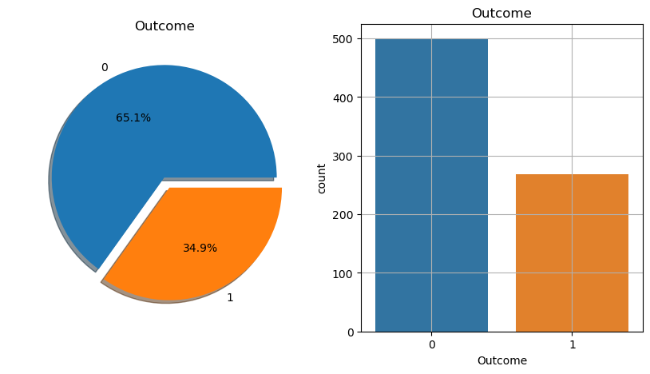

*1 Represent --> Diabetes Positive*

*0 Represent -->* *Diabetes Negative*

Histograms:Visualize the distribution of numerical features like age, glucose levels, BMI, etc. Histograms help you understand the data's central tendencies and spread.

Pie Charts: Use pie charts to visualize the distribution of categorical variables, such as the percentage of people with and without diabetes.

Line Charts: If your data has a temporal aspect, create line charts to observe trends over time. For example, tracking glucose levels over weeks

INPUT

df.hist(bins=10, figsize=(10, 10))  
plt.show()

OUTPUT

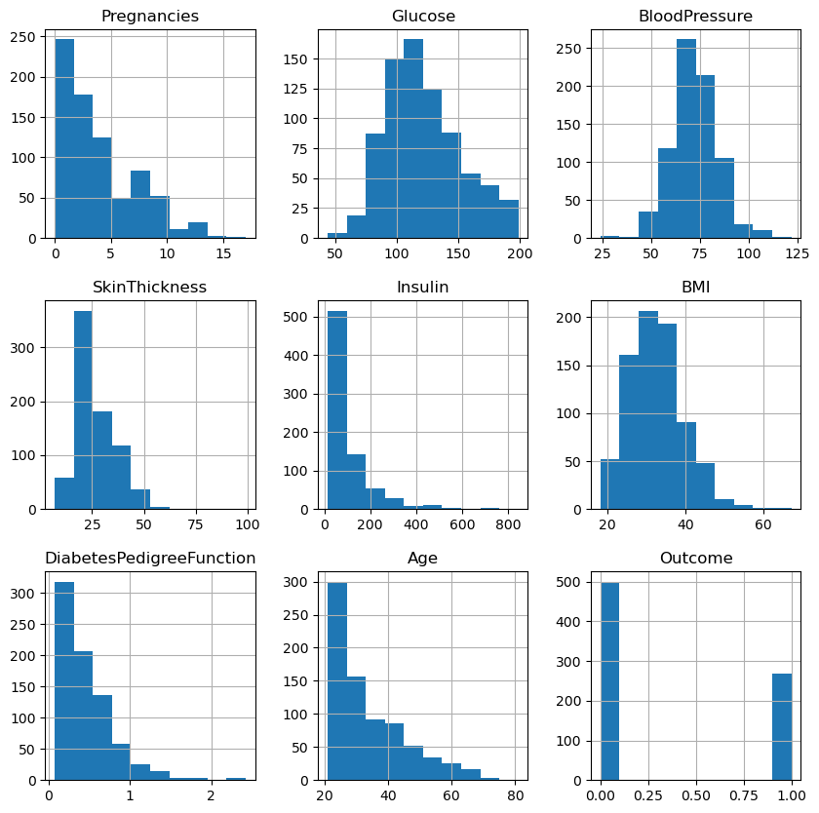

Scatter Plots: Plot relationships between two numerical features to identify correlations and patterns. For instance, you can plot glucose levels against BMI.

INPUT

from pandas.plotting import scatter_matrix  
scatter_matrix(df, figsize =(20, 20))

OUTPUT

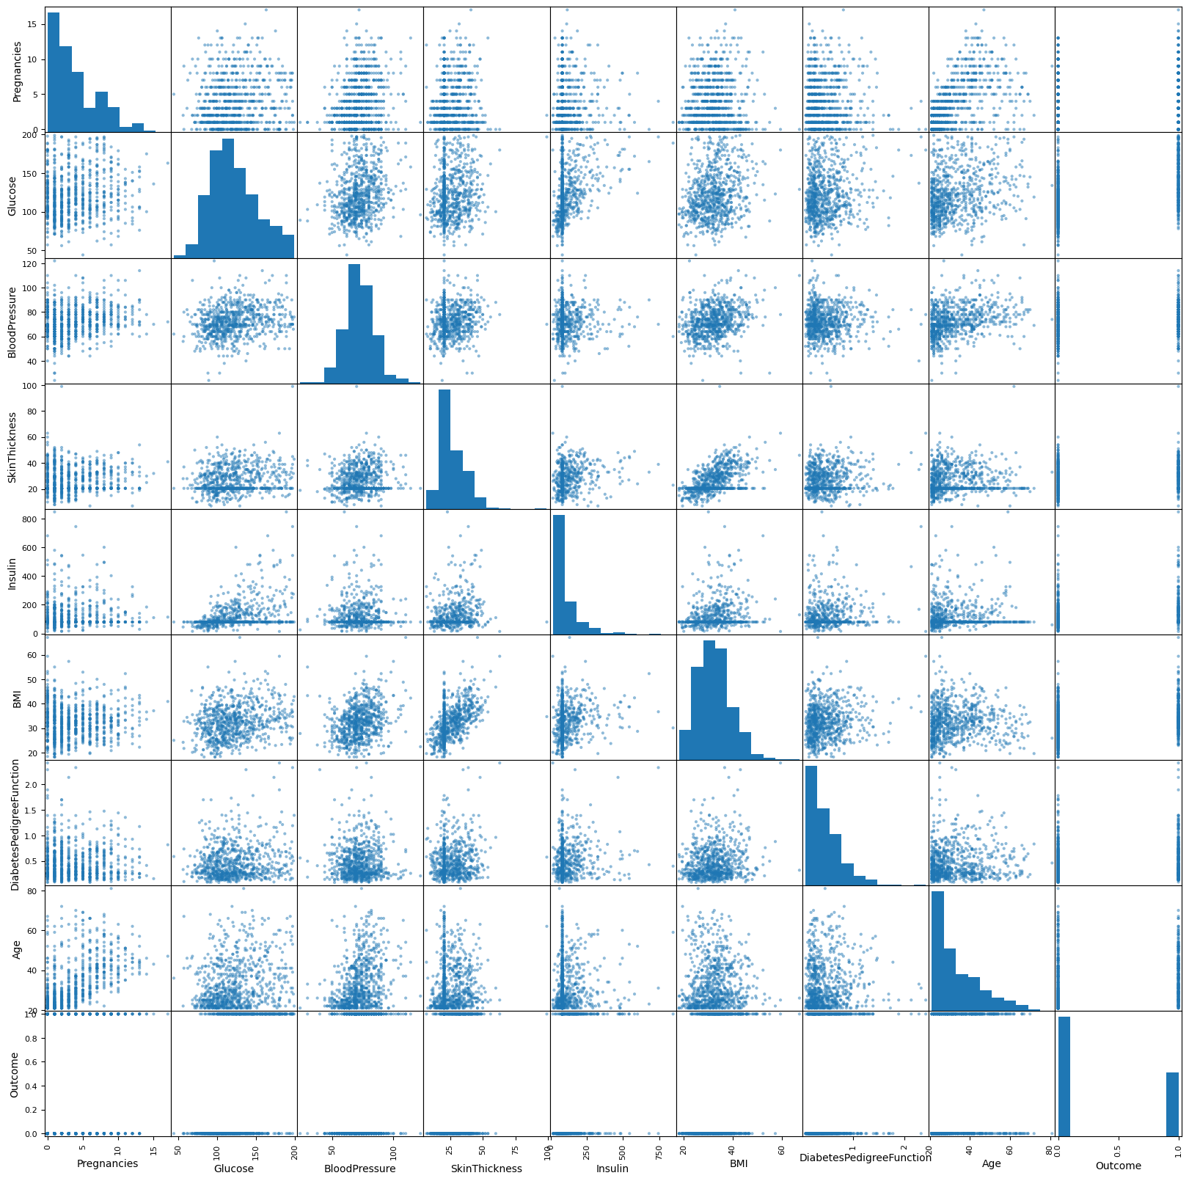

Pair Plots: Plot pairs of features against each other, especially when you have multiple numerical features. Pair plots help in visualizing relationships within the dataset.

Pair Plots: Plot pairs of features against each other, especially when you have multiple numerical features. Pair plots help in visualizing relationships within the dataset.

Violin Plots: Violin plots combine a box plot and a kernel density plot to visualize the distribution of numerical features.

INPUT

sns.pairplot(data=df, hue='Outcome')  
plt.show()

OUTPUT:

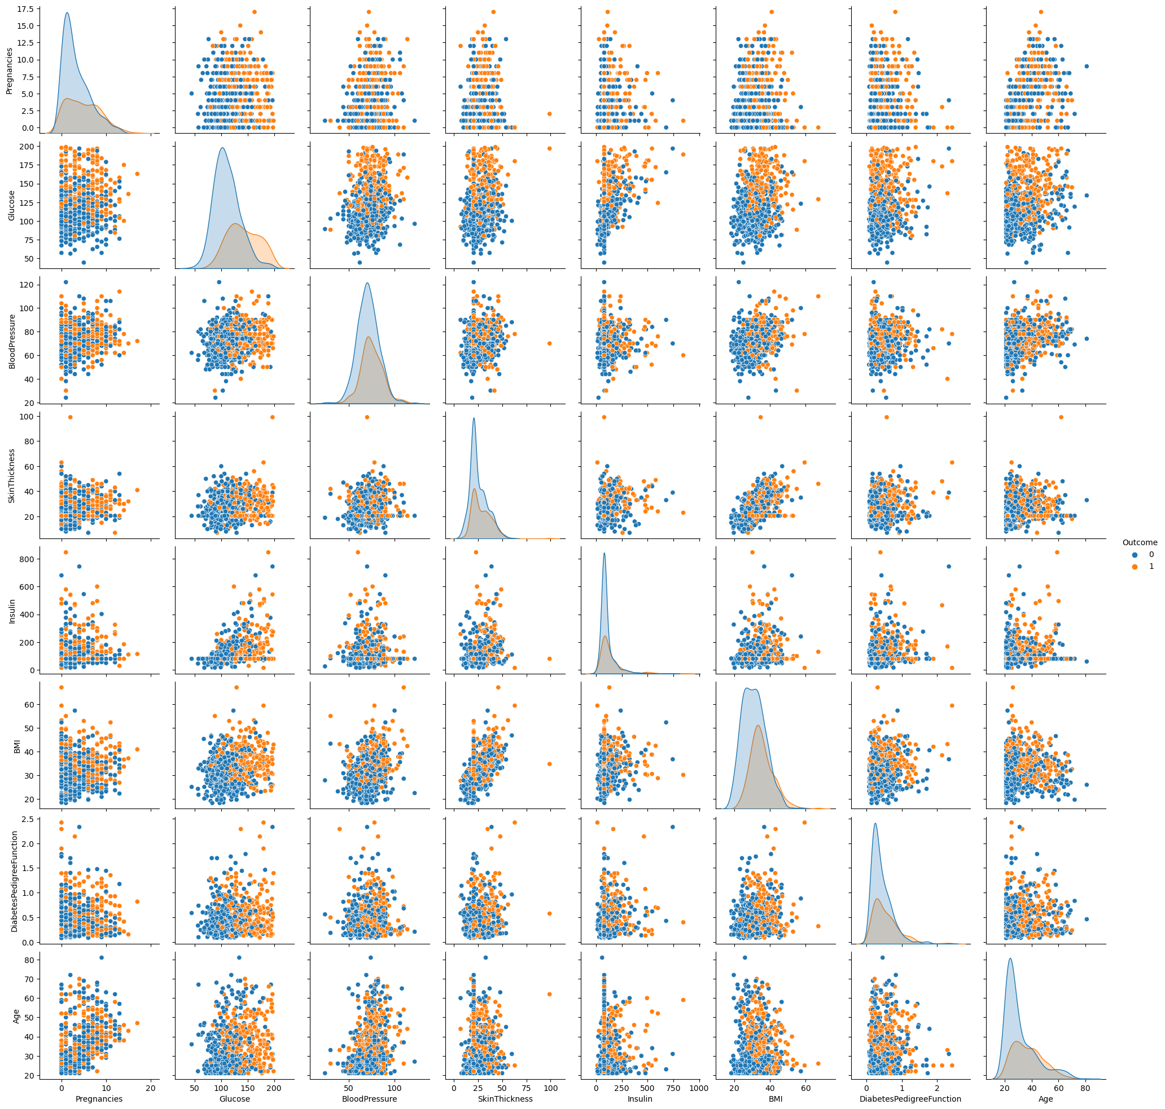

Correlation Heatmaps: Create a heatmap to show the correlation between numerical features. This helps you understand how features relate to each other.

INPUT

plt.figure(figsize=(12, 6))  
sns.heatmap(df.corr(), annot=True, cmap='Reds')  
plt.plot()

OUTPUT

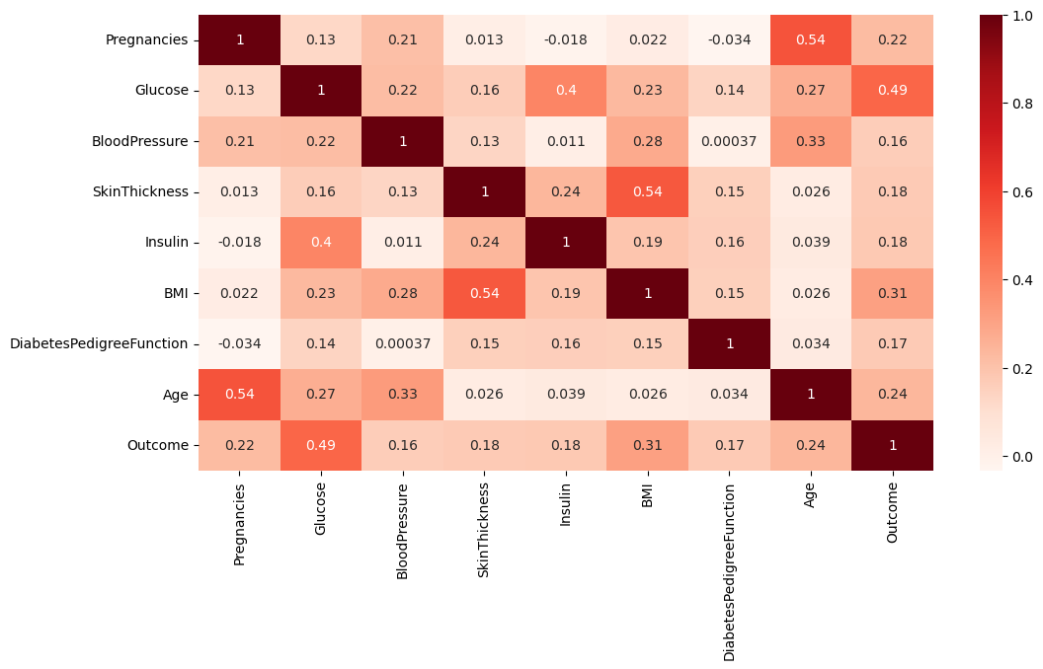

INPUT

mean = df['Outcome'].mean()

OUTPUT

0.3489583333333333

SPLIT THE DATA FRAME INTO X AND Y

INPUT

target_name='Outcome'  
y=df[target_name]  
X= df.drop(target_name, axis=1)

X.head()

OUTPUT

|  |  |  |  |  |  |  |  |  |
| --- | --- | --- | --- | --- | --- | --- | --- | --- |
| S:NO | Pregnancies | glucose | Blood  pressure | Skin  thickness | Insulin | BMI | Diabetes  Pedigree  function | Age |
| 0 | 6 | 148.0 | 72.0 | 35.000000 | 79.799479 | 33.6 | 0.627 | 50 |
| 1 | 1 | 85.0 | 66.0 | 29.000000 | 79.799479 | 26.6 | 0.351 | 31 |
| 2 | 8 | 183.0 | 64.0 | 20.536458 | 79.799479 | 23.3 | 0.672 | 32 |
| 3 | 1 | 89.0 | 66.0 | 23.000000 | 94.000000 | 28.1 | 0.167 | 21 |
| 4 | 0 | 137.0 | 40.0 | 35.000000 | 168.000000 | 43.1 | 2.288 | 33 |

INPUT

y.head()

OUTPUT

0 1  
1 0  
2 1  
3 0  
4 1  
Name: Outcome, dtype: int64

FUTURE SCALING: Scaling an AI-based diabetes prediction system involves a multidisciplinary approach that combines expertise in healthcare, AI, data science, and technology. Continuous learning, adaptation, and collaboration are key elements in the successful scaling of such system

**INPUT**

from sklearn.preprocessing import StandardScaler  
scaler = StandardScaler()  
scaler.fit(X)  
SSX = scaler.transform(X)

from sklearn.model_selection import train_test_split  
X_train, X_test, y_train, y_test = train_test_split(SSX, y, test_size=0.2, random_state=7)

X_train.shape, y_train.shape

OUTPUT

((614, 8), (614,))

INPUT

X_test.shape, y_test.shape

OUTPUT

((154, 8), (154,))

* The following are the steps to be followed after completing the loading and preprocessing of dataset.

Model Building: Choose an appropriate machine learning algorithm for your diabetes prediction task. Common choices include logistic regression, decision trees, random forests, or support vector machines.

Model Training: Train the chosen model on the training dataset using appropriate algorithms and hyperparameters. You may need to perform hyperparameter tuning to optimize model performance.

Model Evaluation: Evaluate the model's performance on the testing dataset using metrics like accuracy, precision, recall, F1-score, and ROC AUC.

Fine-Tuning: Based on the evaluation results, fine-tune the model or try different algorithms to improve predictive performance.

Deployment: Once satisfied with the model's performance, you can deploy it in a real-world setting for diabetes prediction.

Monitoring and Maintenance: Continuously monitor the model's performance and retrain it periodically to ensure it remains accurate and up to date.

Conclusion:

* Understanding the data’s structure, characteristics and any potential issues through exploratory data analysis (EDA) is essential for informed decision-making.
* Data preprocessing emerged as a pivotal aspect of this process. It involves cleaning, transforming, and refining the dataset to ensure that it aligns with the requirements of machine learning algorithms.
* With these foundational steps completed, our dataset is now primed for the subsequent stages of building and training a house price prediction model.